9/28/2018

Group Name: Genesis

Name of Members USI:

Kelvin Morrison 1028679

Noel Farley 1027234

Valon Madramootoo 1028391

Zhi cheng su 1028141

Lecture Girendra Persaud

**CSE 2012 DATABASE SYSTEMS DESIGN AND INFORMATION MANAGEMENT**

Database Requirement Specification Document



Database Requirements

Specification

Time tracker 1.0

30⁰N Travelled service

Prepare by Kelvin Morrison

Date: October 15th, 2018

Revision Sheet

|  |  |  |
| --- | --- | --- |
| **Release No.** | **Date** | **Revision Description** |
|  |  |  |
|  |  |  |
| Rev .0 | 09/12/18 | Content adhere to relevant parts of the template |
| Rev .1 | 10/15th/18 | E-R and Relationship Diagram was added |
|  |  |  |
|  |  |  |
|  |  |  |
|  |  |  |

Table of Contents

Sign offs 5

Introduction 7

Problem Statement 7

Purpose 7

INTENDED AUDIENCE AND READING SUGGESTIONS 8

Scope 8

System overview 9

DATABASE ADMINISTRATIVE INFORMATION 11

Responsibility 11

User class and Characteristics 11

User Class 1 – Owner 12

• Functional requirement 12

Users Class 2- Owners and Administrators 12

• Functional requirement 12

Users Class 3- Drivers 12

• Functional requirement 12

Operating Environment 13

Storage Requirement 13

Functional Requirements 14

Distributed Database: 14

Client/Server System 14

User Interface 14

NONFUNCTIONAL REQUIREMENTS 15

Performance requirements 15

E R Diagram 15

Normalization 17

Safety Requirements 17

Security Requirements 17

Software Quality Attributes 17

Implementation 18

Phase one 18

Phase 2 18

Phase 3 18

Error Handling 19

Data lost 19

Accidental Data Deletion 19

Power failure 19

Hardware failure 19

Acronyms and Abbreviations 20

Points of Contact 21

Information 21

# Sign offs

We have carefully assessed the Database Specifications for the (Time Tracker 1.0). This document has been completed in accordance with the requirements of 30⁰ N System specifications for Development Methodology.

MANAGEMENT CERTIFICATION - Please check the appropriate statement.

______ The document is accepted.

______ The document is accepted pending the changes noted.

______ The document is not accepted.

We fully accept the changes as needed improvements and authorize initiation of work to proceed. Based on our authority and judgment, the continued operation of this system is authorized.

______________________________ _____________________

NAME DATE

Project Leader

______________________________ _____________________

NAME DATE

Operations Division Director

______________________________ _____________________

NAME DATE

Program Area/Sponsor Representative

_______________________________ _____________________

NAME DATE

Program Area/Sponsor Director

_____________________

NAME DATE

Program Area/Sponsor Director

# Introduction

This document defines the normative content of the software requirements specification. Organization of the information items in the document such as the order and section structure may be selected in accordance with the project's documentation policies.

## Problem Statement

30 ⁰N is a taxi services that estimates its charges base on the time it takes to travelled from one point to another.

However sometimes the drivers of the company vehicles forget to log the time they start the journey, and this causes some problem since a customer cannot be charged fairly.

Furthermore, customers are also complaining that some drivers are taking the longest route and wasting their time. So, Mr. Zod the owner and CEO of the company will like the implementation of a system to keep track of time while managing the route of travelled.

## Purpose

The goal of this document is to give detail description of the Time Tracker 1.0 database and all other components that are required for its optimal performance it also describe all functional and nonfunctional requirements of the time tracker 1.0 application for 30 ⁰N.

## INTENDED AUDIENCE AND READING SUGGESTIONS

This Project is a prototype for the Time Tracker 1.0 and is therefore restricted within 30˚N and the developing team.

## Scope

The “Time Tracker 1.0” database is intended to interact with a mobile base GPS application and other mobile time keeping hardware. It will automate the time keeping process. This function will intercorporate with a GPS road mopping application that will help drivers find the closest possible route to their destination. The TT 1.0 will also calculate the charge for the service delivered and print out an invoice for the corresponding service while keeping a digital log of all transactions.

# System overview

The Time Tracker 1.0 database is intended to interface with three level of users. Owner, Management and the drivers of the company vehicles.

All data related to customers travelled will be capture and recorded on a web base server, management are required to set and adjust their hourly rates.

A mobile GPS-Navigator software application will interact with the database about vehicle location and route of travel, it is required that the necessary hardware be installed onboard the company vehicles that is intended to log data in the Database.

The mobile application requires both Internet and GPS connection to fetch and receive information about time of travelled and closest possible route. Between drivers and the database.

The major features of the Time Tracker 1.0 Database system are shown in the entity relationship model below. (ER model)

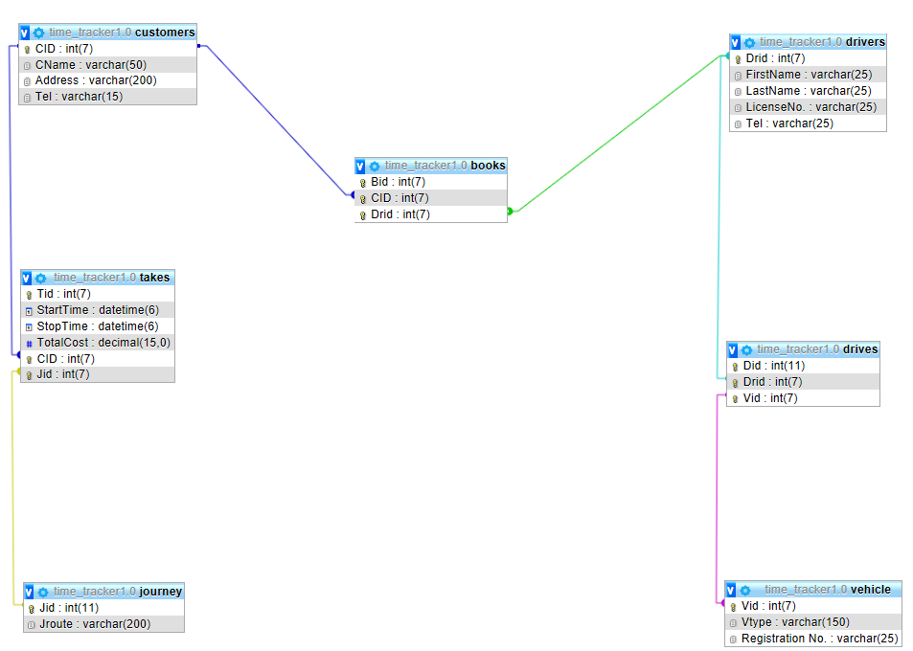

# DATABASE ADMINISTRATIVE INFORMATION

## Responsibility

The Owner Of 30 ⁰ N will be responsible for the manage and overlooking the database. All administrative functions will be carried out by staff or any organization specified by the owner of the entity.

## User class and Characteristics

A first-time user of the system must be giving login privilege by an upper level staff. While these privileges are not granted, if a user is continuously trying to log in, the system will flag the unauthorized used while alerting management about the security breach and make a log of the time and devices IP that attempt to gain entry.

Every user that interact with the system will have access to different functions base on the level of privilege granted to them, User can set the mobile application to his/her preferred language.

Instruction about route of travel and time will displayed base on mopping data stored in the data base.

The System will interact with three level of users:

* User Class 1- Owner of Entity
* User Class 2 - Entity Owner and administrators
* User Class 3 – Drivers

Users at each level of the system will have access to different user functionality specific to their job requirements.

User Class 1 – Owner

* Functional requirement
* Set Access level of other users.
* Has the authority to add or remove user from the system.
* Manage and regulate the entire database.
* The rights to permanently delete any users.

Users Class 2- Owners and Administrators

* Functional requirement
* Have the responsibility for regulating the hourly rates in the database.
* Creating logging for level three users.
* Keep track of the location of vehicles.

Users Class 3- Drivers

### Functional requirement

* Log in to the mobile device that interface with the database set destination.

## Operating Environment

The operating environment for the Time Tracker 1.0 is listed below.

Distributed database

Web base server

Operating system: Windows.

Database: SQL database.

Platform: PHP/ MYSQL:

## Storage Requirement

It is estimated that the database will require a terabyte (1024 GB) of data storage space on start up. More storage space may be required due to maintenance, update and storage of mopping and travelling data.

**Redundant Data**

This will be recycled automatically.

# Functional Requirements

## ****Distributed Database:****

A single application should be able to operate transparently on data that is spread across a variety of different databases and connected by a communication network This is necessary for future Expansion.

## Client/Server System

The architecture design of the Time Tracker 1.0 will feature both a client and Server application.

## User Interface

Both Client and Server will have separate means by which they are access

# NONFUNCTIONAL REQUIREMENTS

## Performance requirements

These are the steps involved to perform the implementation of TT 1.0 database

## E R Diagram

The E-R Diagram constitutes a technique for representing the logical structure of the database in a pictorial manner. The analysis is used to organize the data as a relation, normalizing relation and obtaining a relation database.

* **Entities:** Specify distinct real-world items in an application.
* **Attributes:** Specify properties of an entity and relationships.
* **Relationship:** Which connect entities and represent meaningful dependencies between them.

ER Diagram

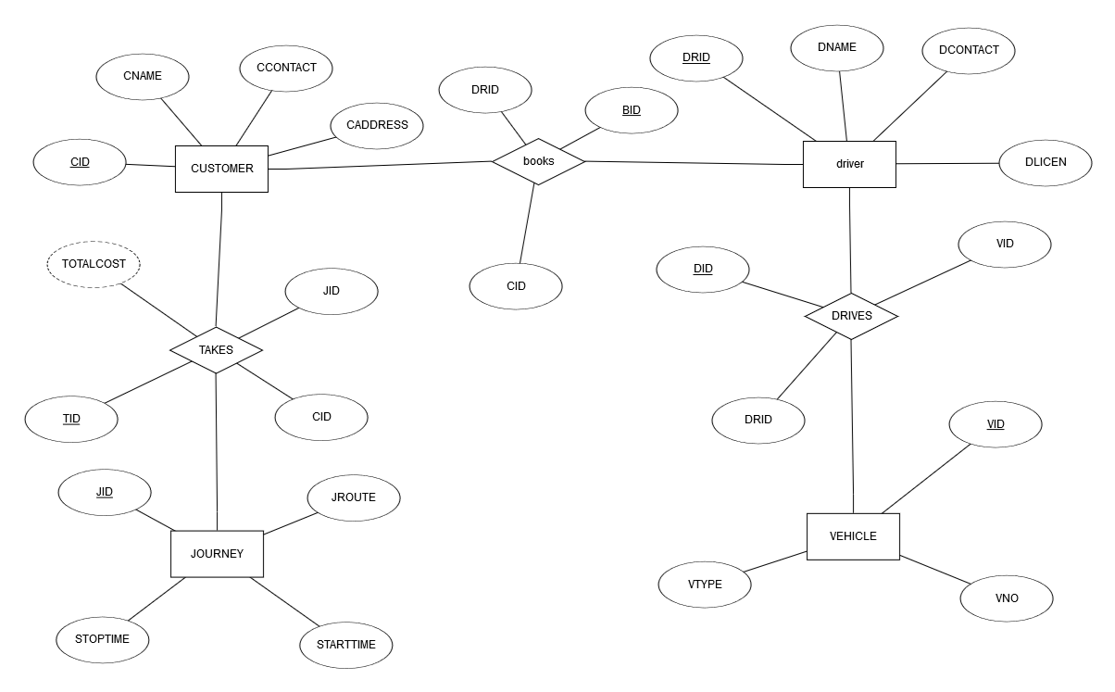

## Normalization

The means of ensuring that information is only stored once. Storing the same information several times will leads to wastage of storage space and increase in the total size of the data stored.

## Safety Requirements

Are the means of putting systems in place to back up and recover system data to be use in the event of extensive damage to the database due to catastrophic failure.

## Security Requirements

Involves all actions taken to ensure safety and integrity of the database.

## Software Quality Attributes

* **AVAILABILITY:**

Information regarding access rout should be readily available on request.

* **CORRECTNESS:**

All data regarding to route and charges should be accurate

* **MAINTAINABILITY:**

The administrators or manager in chargers should be able to easily maintain or correct charge data.

* **USABILITY**

The mobile interface should be easy to navigate.

# Implementation

The system will function on MYSQL and be deployed in three phases

## Phase one

* **Installing and integrating of mobile devices on all vehicles**

During this process the GPS navigation system, time tracking hardware and the mobile broadband devices will be placed onboard the vehicles also sample street mopping data will be collected.

## Phase 2

* **Implementation of a time management system**

The clocking system for the time tracking hardware will be integrated to work along with the GPS Navigator. Testing will be done during this phase to ensure the clocking system function at it was intended.

## Phase 3

* **Capturing and Billing**

The prices are set and coordination with the clocking system to generate charges. Recording of GPS data and generating invoices base on time of travel.

# Error Handling

## Data lost

The database will be systematically backup to reduce lost of data. It will require an independent server to run on.

## Accidental Data Deletion

All Deleted Data will remain in a recycle bin for twenty 20 days before permeant deletion

## Power failure

A backup system along with a generator will be employed.

## Hardware failure

In the event of fire, flood or any other disaster all data could be recovered from an offsite server

Logical Database design

# Acronyms and Abbreviations

|  |  |
| --- | --- |
| **Acronyms** | **Abbreviations** |
| GPS | Global Positioning System |
| TT | Time Tracker |
| DESC | Description |
| DBMS | Database Management System |
|  |  |

# Points of Contact

Computer Science Department

## Information

Kelvin Morrison

Email [kelvin_morrison97@yahoo.com](mailto:kelvin_morrison97@yahoo.com)

Tell 5926888913